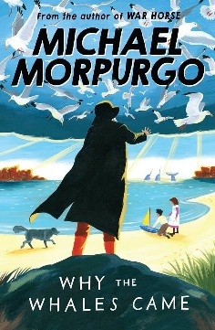  Reading:  Our class novel is:  Over the coming weeks please bring your home reader into school every day and log it when read in your reading log. When reading for pleasure at home, this can also be logged.  Reading logs will be checked periodically in school. Parents are asked to make comments when reading with their children. books to be changed on a |  |  | Maths:  Continue to practise basic skills to gain math badges during Monday’s assembly.  BLUE –number bonds to 20  GREEN – x2, x5, x10 timestables and division facts  BRONZE – x3, x4, x8 timestable and divison facts  SILVER – x6, x7, x9 timestable and division facts  GOLD – x11, x12  PLATIUM – special numbers (squares, primes etc) |  | Creative Topic Project:  We are learning about the Anglo-Saxons in our History lessons.  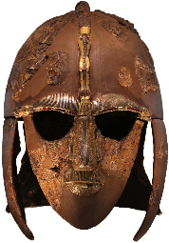  You can create any project you wish. This may be a writing project, a presentation or drawing/making an Anglo-Saxo artefact.  The children will have chance to show their projects in the last week of term before Christmas.
Friday 18th September  Words containing the prefix ‘in’  inactive  incorrect  invisible  insecure  inflexible  indefinite  inelegant  incurable  inability  inaccurate | Friday 25th September  Homophones  accept  except  knot  not  peace  piece  plain  plane  weather  whether | Friday 2nd October  Words containing the prefix ‘sub’  submarine  subject  subway  submerge  subtropical  subdivide  subheading  substandard  subtitle  submit |  | Friday 9th October  Words containing the prefixes ‘il-‘ and ‘ir-‘  illegal  illegible  immature  immortal  impatient  irregular  irrelevant  irresponsible | Friday 16th October  Words containing the prefix ‘inter’  interact  intercity  international  interfere  interview  intercept  intercom  internet  interchange  interface | Friday 23rd October  Year 4 common exception words  address  answer  appear  believe  breath  build  calendar  caught  circle  decide  different  difficult

