Welcome!
Welcome back to school! I hope that you all had a lovely break and enjoyed family time together.
My non-working day will continue to be a Friday. Mrs Crompton will teach the children on a Friday.

Literacy

To start the summer term, we will complete our spyware adverts and begin a discussion based on the text Bill’s New Frock. We will innovate our class text and eventually write our own.
We will read every day. This will be a shared reading session four times a week and throughout the week your child will read with us in school. They will bring their reading books home to share with you. Please sign their reading log, adding any comments where appropriate.
Your child will be given spellings on their homework sheet. Your child will be tested on a Monday. They will also bring home handwriting practice sheets; it is important that they practice to improve their presentation.

Numeracy
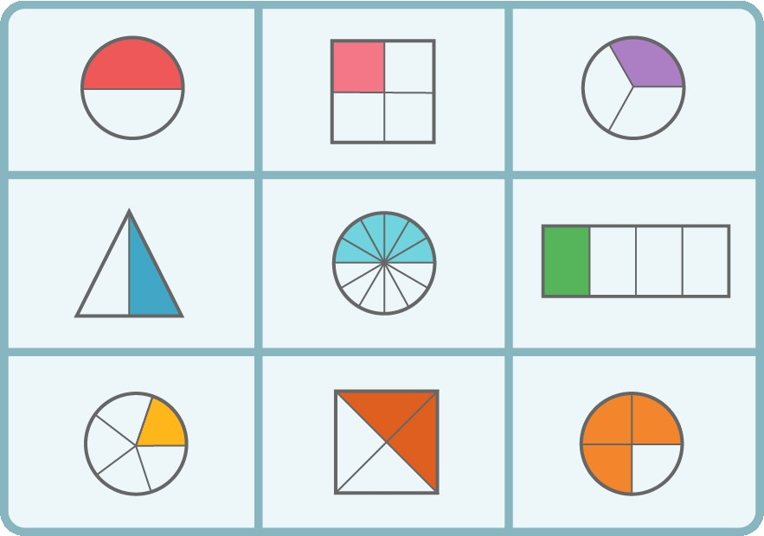
In maths, we will complete multiplication and division and begin fractions. Whenever possible practise times tables and related division facts. If you need another fact sheet, let me know. If your child is in Y4, it is important that they practise regularly for their multiplication assessment this term. This is a good link to use and the children have used it before.
https://mathsframe.co.uk/en/resources/resource/477/Multiplication-Tables-Check
Science

Our science unit is Plants and then light. We will identify and describe the functions of different parts of flowering plants. We will explore requirements for plants to survive and investigate how water is transported within plants.
Dates for the Diary/ Information
Please look out for newsletters containing future dates.
Information about Year 3/4 can also be found on the school website in the class section.
Foundation Subjects
Please see the school website for further details about this term’s learning in art, DT, history, geography, RE, PE, PSHE and music.
www.walbottlevillage.newcastle.sch.uk
Things to remember….
- Please send your child into school wearing their PE kit on a Monday and Friday. Ensure it is appropriate for the weather.
- Please bring your child’s reading book into school daily.
- Please sign your child’s reading log and comment about how they got on with their book or any other book they may be reading.
- Spellings will be tested on a Monday.
- You will receive a homework sheet every half term, which will explain our creative project.
- You will receive a weekly handwriting sheet.
- Please practise spellings, times tables and division facts as often as possible.
Thank you for your support at home!

Year 3/4

Curriculum Booklet



Summer 2026

