Year 5 Spelling Worksheet

Due: 9th May
Find your spellings in the word search:  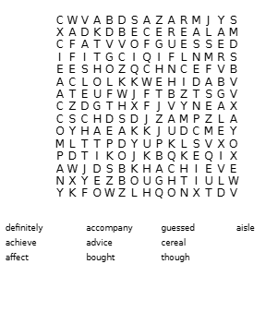 | Find and write the definition of each word:
  advice
  definitely
  guessed
  achieve
  accompany
  cereal
  aisle
  affect
  bought
  though

Use your joined handwriting to write out each word as neatly as you can:  --------------------------------------  --------------------------------------  --------------------------------------  --------------------------------------  --------------------------------------  --------------------------------------  --------------------------------------  --------------------------------------  --------------------------------------  -------------------------------------- | Look, copy, cover and check:
  Look | Copy | Cover & Write | Check
  advice
  definitely
  guessed
  achieve
  accompany
  cereal
  aisle
  affect
  bought
  though
Please complete each activity carefully:

