Welcome!
Welcome back to school! I hope that you all had a lovely break and enjoyed family time together.
My non-working day will continue to be a Friday. Mrs Conway will teach the children on a Friday. Year 3 will continue to be supported by our teaching assistant Mrs Brown.

Literacy
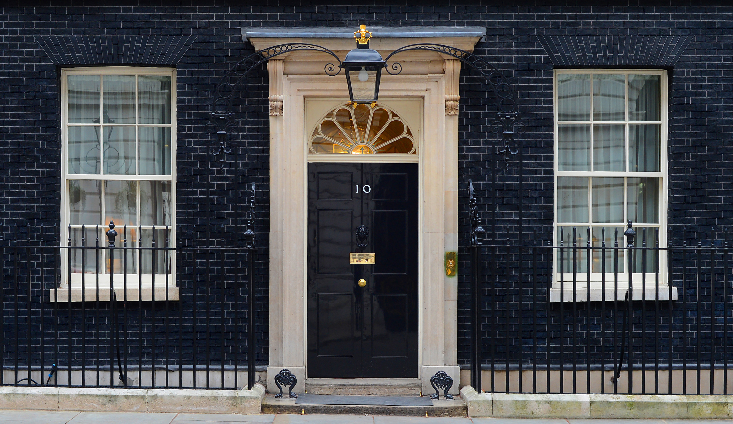
To start the summer term we will look at persuasive letters to the PM, using a poem called Rang Tan as our starting point. We will innovate our class text and eventually write our own.
We will read every day. This will be a shared reading session four times a week and throughout the week your child will read with us in school. Thy will bring their reading books home to share with you. Please sign their reading log, adding any comments where appropriate.
Your child will be given spellings on their homework sheet and they will also be available on ‘Spelling Shed’. Your child will be tested on a Monday.

Numeracy
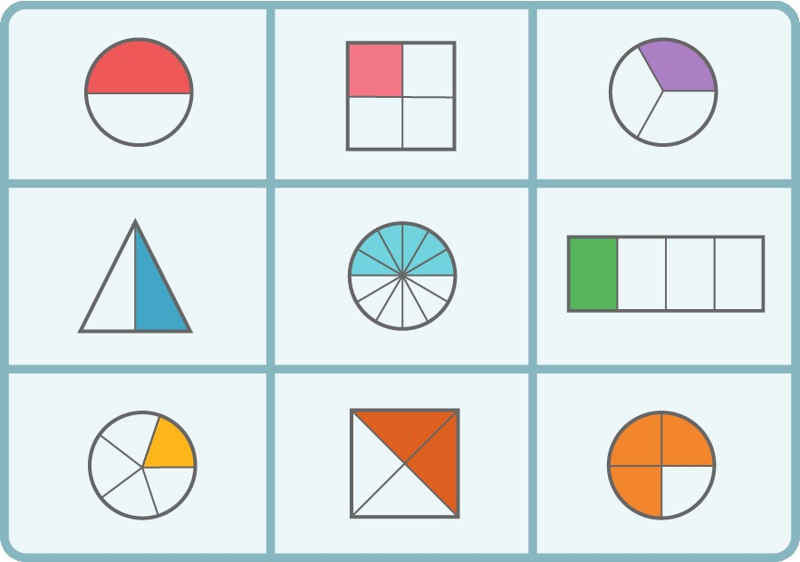
In maths, we will continue with fractions and then start work on mass and capacity. Whenever possible practise times tables and related division facts. If you need another fact sheet, let me know. Your child will have a facts test every half term, linked to their ability and the maths badge they are working on. Maths shed will have the up to date facts to practise.

Science

Our science unit is Forces and Magnets followed by plants and then light. We will find out what forces there are and investigate the forces on different surfaces. Children will sort magnetic and non-magnetic materials and investigate the strength. We will find out that we need light to see things and that dark is the absence of light.
Dates for the Diary/ Information
Please look out for newsletters containing future dates. Use Dojo to keep up to date with any news and to send a message if you need to ask me anything. Information about Year 3 will also be found on the school website in the class section.
Foundation Subjects
Please see the school website for further details about this term’s learning in art, DT, history, geography, RE, PE, PSHE and music.
www.walbottlevillage.newcastle.sch.uk
Things to remember….
- Please send your child into school wearing their PE kit on a Thursday. Ensure it is appropriate for the weather.
- Swimming will continue to be on a Tuesday. Please ensure children have their kits and wear their PE kits.
- Please bring your child’s reading book into school daily.
- Please sign your child’s reading log and comment about how they got on with their book or any other book they may be reading.
- Spellings will be tested on a Monday.
- Maths facts, linked to maths badges, will be tested every half term.
- You will receive a homework sheet every half term which will explain our creative project.
- Please practise spellings, times tables and division facts as often as possible.
Thank you for your support at home!

Year 3

Curriculum Booklet



Summer 2024

