Welcome!
Welcome back to school! I hope that you all had a lovely break and enjoyed family time together.
Miss Baird will continue to support across LKS2. I will continue to have my non-working day on a Friday and Mrs Conway will now teach our class on that day.
Literacy
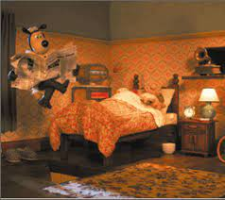
Our first unit of work during the spring term will be explanations, we will be looking at how things work, we will innovate an explanation and eventually write our own.
We will continue to read every day. This will be a shared reading session four times a week and throughout the week your child will read with us in school. They will bring their reading books home to share with you. Please sign their reading log, adding any comments where appropriate.
Your child will be given spellings on their homework sheet and they will also be available on ‘Spelling Shed’. Your child will be tested on a Monday.
Numeracy

In maths, we will continue to look at multiplication and division, the times tables, 3, 4 and 8 and solving problems related to them. Whenever possible practise times tables and related division facts. If you need another fact sheet, let me know. Your child will have a facts test every Thursday, linked to their ability and the maths badge they are working on. Maths shed will have the up to date facts to practise. Please use maths shed, hit the button or maths frame for activities.
Science

Our science unit is Animals, including humans, followed by Plants. We will find out what animals need to survive. We will identify that humans and other animals have skeletons and muscles for support, protection and movement. We will identify and label the parts and functions of flowering plants and explore the requirements for plants to survive. We will investigate how water is transported through plants.

Dates for the Diary/ Information
Please look out for newsletters containing future dates. Information about Year 3 will also be found on the school website in the class section.
Foundation Subjects
Please see the school website for further details about this term’s learning in art, DT, history, geography, RE, PE, PSHE and music.
www.walbottlevillage.newcastle.sch.uk
Things to remember….
- Please send your child into school wearing their PE kit on a Thursday and Friday. Ensure it is appropriate for the weather.
- Please bring your child’s reading into school daily.
- Please sign your child’s reading log and comment about how they got on with their book. If your child reads 3 or more times a week they will receive a golden ticket.
- Spellings will be tested on a Monday and times tables and division facts on a Thursday.
- You will receive a homework sheet every half term, which will explain our creative project and weekly maths homework.
- Please practise spellings, times tables and division facts as often as possible.
Thank you for your support at home!

Year 3
Curriculum Booklet

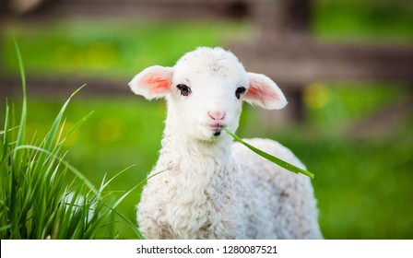

Spring 2025

