Use your joined handwriting to write out each word as neatly as you can:  --------------------------------------  --------------------------------------  --------------------------------------  --------------------------------------  --------------------------------------  --------------------------------------  --------------------------------------  --------------------------------------  --------------------------------------  -------------------------------------- | Look, copy, cover and check:
  Look | Copy | Cover & Write | Check
  giggly
  simply
  horribly
  carefully
  comically
  suddenly
Year 3 Spelling Worksheet
Due: Monday 7th April 2025 – adding the suffix -ly
Find your spellings in the word search:  giggly simply horribly carefully  comically suddenly  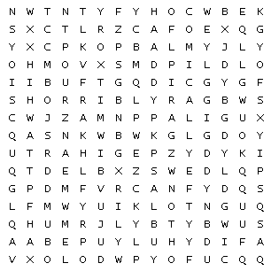 | Find and write the definition of each word:
  giggly
  simply
  horribly
  carefully
  comically
  suddenly

Please complete each activity carefully:

