Use your joined handwriting to write out each word as neatly as you can:  --------------------------------------  --------------------------------------  --------------------------------------  --------------------------------------  --------------------------------------  --------------------------------------  --------------------------------------  --------------------------------------  --------------------------------------  -------------------------------------- | Look, copy, cover and check:
  Look | Copy | Cover & Write | Check
  famous
  nervous
  ridiculous
  dangerous
  mountainous
  hazardous
Year 3 Spelling Worksheet
Due: Monday 31st March 2025 – adding adding the suffix -ous
Find your spellings in the word search:  famous nervous ridiculous dangerous  mountainous hazardous  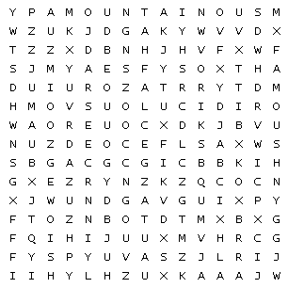 | Find and write the definition of each word:
  famous
  nervous
  ridiculous
  dangerous
  mountainous
  hazardous

Please complete each activity carefully:

