Use your joined handwriting to write out each word as neatly as you can:  --------------------------------------  --------------------------------------  --------------------------------------  --------------------------------------  --------------------------------------  --------------------------------------  --------------------------------------  --------------------------------------  --------------------------------------  -------------------------------------- | Look, copy, cover and check:
  Look | Copy | Cover & Write | Check
  immortal
  impatient
  impolite
  imperfect
  impossible
  immature
Year 3 Spelling Worksheet
Due: Monday 24th March 2025 – adding im- to root words beginning with m or p
Find your spellings in the word search:  imperfect impatient impolite immortal  immature impossible  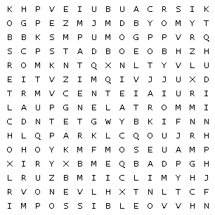 | Find and write the definition of each word:
  imperfect
  impatient
  impolite
  impossible
  immortal
  immature

Please complete each activity carefully:

