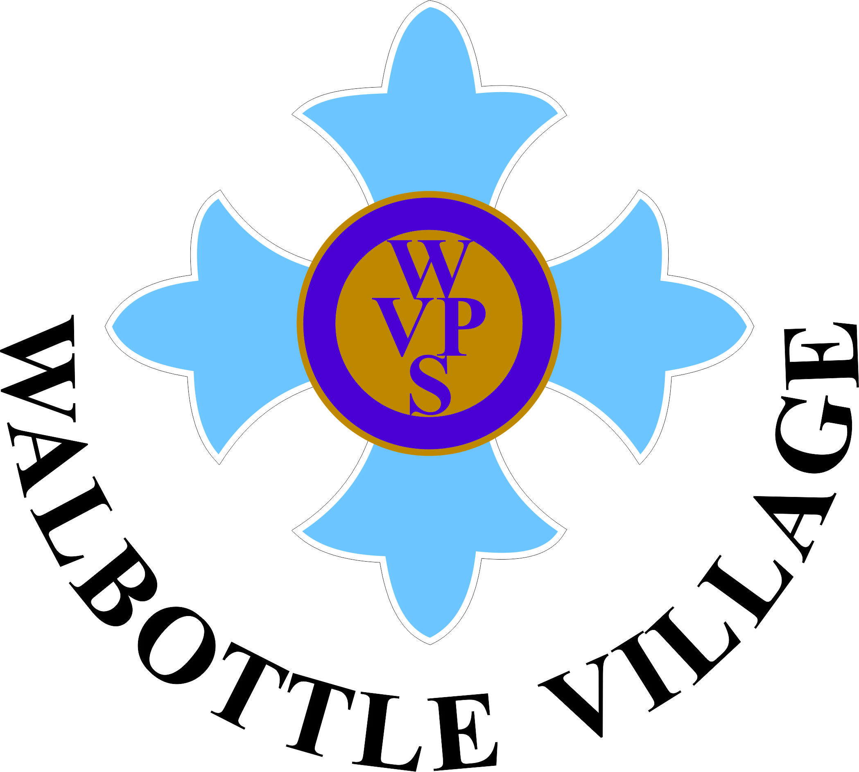

TEACHING, LEARNING & ASSESSMENT
GRADE – OUTSTANDING (1)
Teachers have a deep knowledge of the needs and strengths of each pupil. They use assessment information highly effectively to plan for personalised learning. Through their teaching, teachers demonstrate a deep knowledge and understanding of the subjects they teach. They are able to effectively support learners and address any misconceptions. All groups are supported in order that they succeed. Teachers provide support within lessons and through additional sessions (during assembly and at after school booster classes) for those children falling behind and those who can be challenged further. Differentiated homework provides children with the opportunity to consolidate and extend their learning.
Lessons and sequences of lessons are well structured. Children are guided through the learning journey well. Teachers and support staff model effectively and provide appropriate and timely support within lessons in order that all pupils achieve. Questioning is highly effective, as is the feedback given to pupils within lessons and through high quality marking. Children have the time to respond to feedback.
Pupils demonstrate a love of learning and a thirst for knowledge. They are inquisitive and seek to gather new information and acquire new skills in order to deepen their understanding across the curriculum. Pupils respond well to challenge and show resilience when faced with obstacles. They are supportive of one another and show pride in their own and one another’s achievements. Pupils have the opportunity to use and develop their reading, writing, communication and maths knowledge across the curriculum.
Adults in school have exceptionally high expectations for all pupils in relation to learning and behaviour. Behaviour within lessons and around school is outstanding. Pupils promote the ethos of Walbottle Village well when in and around the community and whilst participating in off site visits, with the office regularly receiving positive feedback from the general public about our pupils.
Pupils are offered a wide range of extra-curricular opportunities (film club, musical theatre, football, games, arts & crafts …) and all children are encouraged to participate in these.
Parents are kept well informed about their child’s learning and progress. All schemes for all topics are shared through our school website. A weekly newsletter keeps parents up to date with activities taking place in school and visits out. Parents are invited in for a termly parent consultation meeting where they have the opportunity to look at their child’s work, be given new targets and find out how they can work with school and support their child at home. We operate an open door policy and parents are welcome to make an appointment to discuss their child at any time. Parents are informed as to whether their child is working at, below or above age related expectations under the new curriculum.
The celebration of diversity and equality of opportunity at Walbottle Village are explicit. The knowledge and experiences of individuals is used to teach others (for example children leading learning around particular faiths). All year 6 pupils are pupil governors of our school and, within their sub committees, work to promote the British Values. They support the younger children in understanding and living by these values. They prepare a termly report which is shared with parents and school governors.

