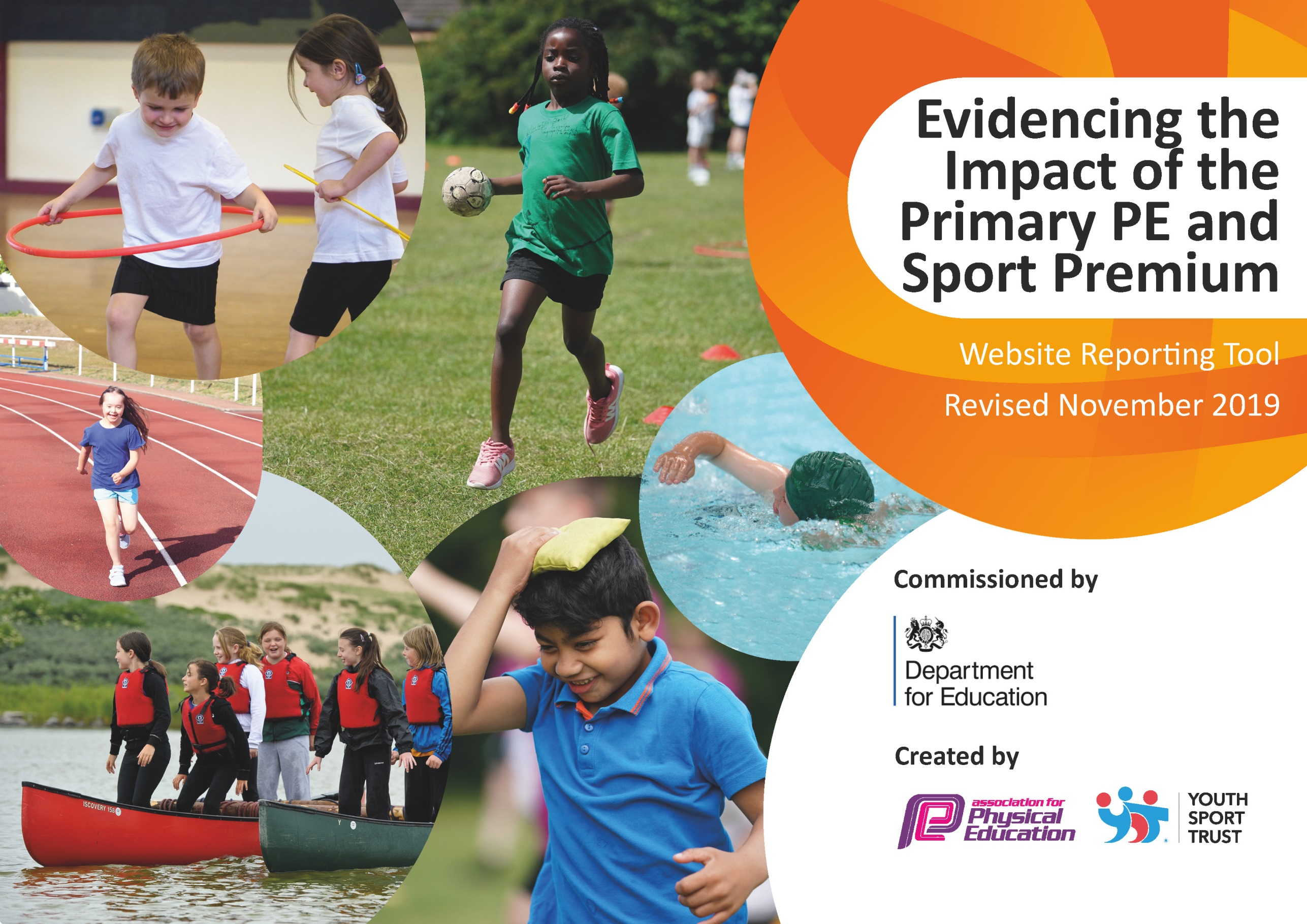
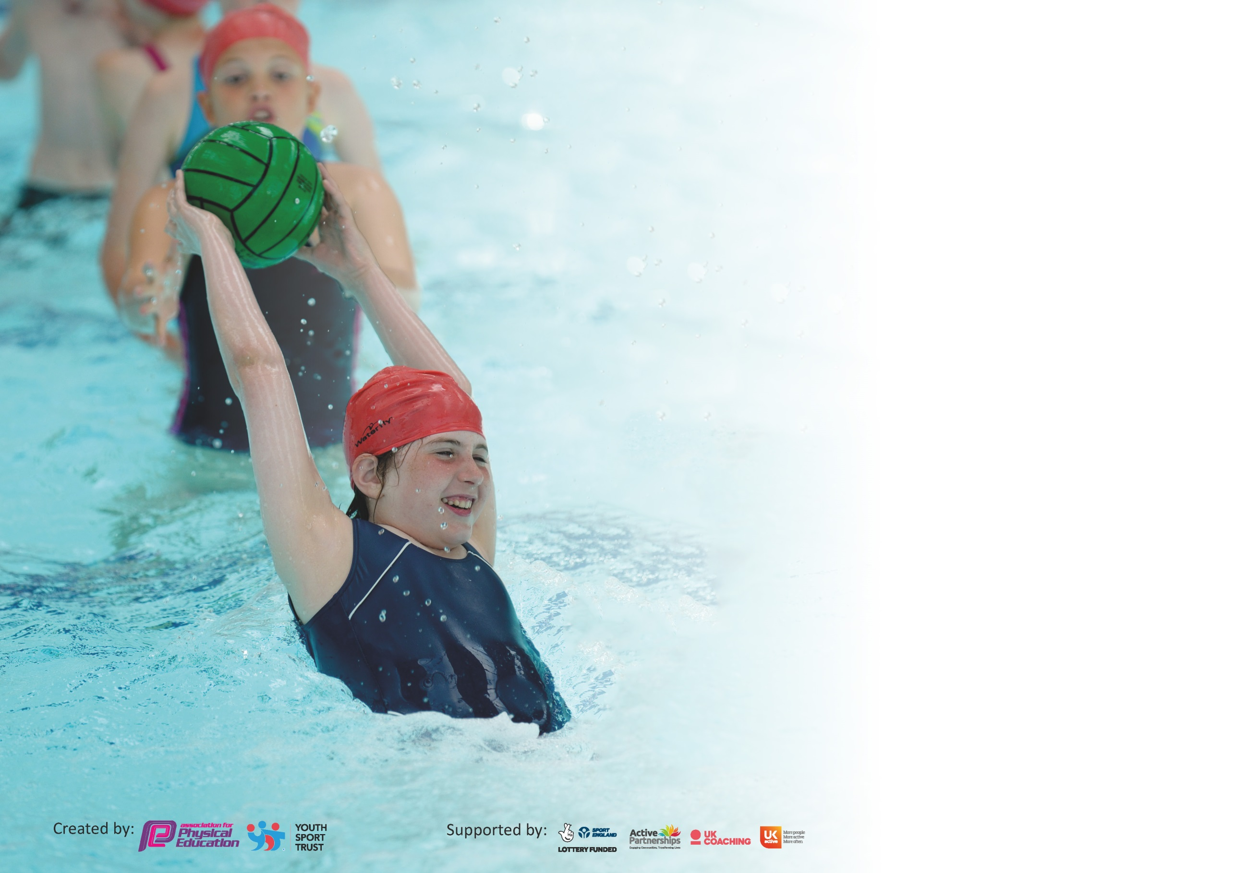

It is important that your grant is used effectively and based on school need. The Education Inspection Framework (Ofsted 2019 p64) makes clear there will be a focus on ‘whether leaders and those responsible for governors all understand their respective roles and perform these in a way that enhances the effectiveness of the school’.

Under the Quality of Education criteria (p41) inspectors consider the extent to which schools can articulate their curriculum (INTENT), construct their curriculum (IMPLEMENTATION) and demonstrate the outcomes which result (IMPACT).

To assist schools with common transferable language this template has been developed to utilise the same three headings which should make your plans easily transferable between working documents.

Schools must use the funding to make additional and sustainable improvements to the quality of Physical Education, School Sport and Physical Activity (PESSPA) they offer. This means that you should
use the Primary PE and Sport Premium to:

- Develop or add to the PESSPA activities that your school already offer
- Build capacity and capability within the school to ensure that improvements made now will benefit pupils joining the school in future years

Please visit gov.uk for the revised DfE guidance including the 5 key indicators across which schools should demonstrate an improvement. This document will help you to review your provision and to report your spend. DfE encourages schools to use this template as an effective way of meeting the reporting requirements of the Primary PE and Sport Premium.

We recommend you start by reflecting on the impact of current provision and reviewing the previous spend.

Schools are required to publish details of how they spend this funding as well as on the impact it has on pupils’ PE and sport participation and attainment by the end of the summer term or by 31st July 2020 at the latest.

We recommend regularly updating the table and publishing it on your website throughout the year. This evidences your ongoing self-evaluation of how you are using the funding to secure maximum, sustainable impact. Final copy must be posted on your website by the end of the academic year and no later than the 31st July 2020. To see an example of how to complete the table please click HERE.

Support for review and reflection - considering the 5 key indicators from DfE, what development needs are a priority for your setting and your pupils now and why? Use the space below to reflect on previous spend and key achievements and areas for development.

Key achievements to date until July 2019: | Areas for further improvement and baseline evidence of need:
- We have appointed specific coaches to deliver a wide variety of sport-related activities over a lunch time. These have been equally distributed throughout all school year groups. There has been a marked improvement on engagement and ability in PE lessons as a result of this and pupil voice surveys indicate a high level of participation and enjoyment.  - School games leaders are working working with small groups of younger children. They are responsible for games and equipment. This has had a marked improvement on behaviour in younger year groups.  - Coaches have continued to upskill teaching staff with particular focus on assessment of the PE curriculum. | - Revamp the PE curriculum for academic year 2020-2021 to ensure more progression in particular with reference to strike and field/ net and wall sports.  - Increase participation in school games/ competitive events in academic year 2020-2021.

Meeting national curriculum requirements for swimming and water safety.
What percentage of your current Year 6 cohort swim competently, confidently and proficiently over a distance of at least 25 metres?  N.B. Even though your pupils may swim in another year please report on their attainment on leaving  primary school at the end of the summer term 2020. | 56%
What percentage of your current Year 6 cohort use a range of strokes effectively [for example, front crawl, backstroke and breaststroke]? | 42%
What percentage of your current Year 6 cohort perform safe self-rescue in different water-based situations? | 56%
Schools can choose to use the Primary PE and Sport Premium to provide additional provision for swimming but this must be for activity over and above the national curriculum requirements. Have you used it in this way? | Yes/No

Action Plan and Budget Tracking
Capture your intended annual spend against the 5 key indicators. Clarify the success criteria and evidence of impact that you intend to measure to evaluate for pupils today and for the future.

Academic Year: 2018/19 | Total fund allocated: £ | Date Updated:
Key indicator 1: The engagement of all pupils in regular physical activity – Chief Medical Officer guidelines recommend that primary school pupils undertake at least 30 minutes of physical activity a day in school |  |  |  | Percentage of total allocation:
 |  |  |  | %
Intent | Implementation |  | Impact
Your school focus should be clear what you want the pupils to know and be able to do and about  what they need to learn and to  consolidate through practice: | Make sure your actions to achieve are linked to your intentions: | Funding allocated: | Evidence of impact: what do pupils now know and what can they now do? What has changed?: | Sustainability and suggested next steps:
Encourage an increased amount of active minutes for all children in school. | Develop extra-curricular activities by implementing an increased lunchtime and after-school club timetable. Encourage children who are not regular attendees at after-school club to attend lunch time clubs to ensure more active minutes during the school day.  Increase active minutes throughout the school day by encouraging active assemblies and active breakfast club as well as ensuring enrichment has a minimum of 1 active club.  EYFS to have daily access to outdoor areas in line with child-led play. | Lunchtime clubs: £1080  After-school clubs: £1981  Sports leaders: £275 | Lunchtime staff have reported improved behaviour at lunch time.  Increased participation in both lunch time and after-school clubs. With previously identified, non-active children (children who did not attend any school sport clubs or out of school clubs) now taking part.  Pupil voice surveys indicate increased participation in sport both in and outside of school as well as increased enjoyment. | Next year, work alongside LA to devise a timetable for both lunchtime and after-school clubs which corresponds to school games calendar to allow both curricular and extra curricular PE to support increased participation in competition.
Key indicator 2: The profile of PESSPA being raised across the school as a tool for whole school improvement |  |  |  | Percentage of total allocation:
 |  |  |  | %
Intent | Implementation |  | Impact
Your school focus should be clear what you want the pupils to know and be able to do and about  what they need to learn and to  consolidate through practice: | Make sure your actions to achieve are linked to your intentions: | Funding allocated: | Evidence of impact: what do pupils now know and what can they now do? What has changed?: | Sustainability and suggested next steps:
In line with poverty proofing audit, make children and parents aware of sporting opportunities in our local area to increase participation and reduce poverty of experience. | Invite local companies into school to deliver curricular PE lessons with a view to encourage participation outside of school. These to include:  Newcastle Eagles  Newcastle Badminton Club  Northumberland County Cricket  Ponteland Rugby Club  Plus others dependent on feedback from pupil voice survey.  Send out questionnaire for parents to complete based on clubs their children currently attend/ speak to pupils about clubs they currently attend to produce a directory for parents to use. | £685- external coaches to deliver PE in school with a view to increase engagement in sport outside of school. | Children and parents are more aware of opportunities outside of school. Some children reported that they would like to join clubs and parents were going to make contact. | Continue to work with local clubs and provision to increase directory and engagement.

Key indicator 3: Increased confidence, knowledge and skills of all staff in teaching PE and sport |  |  |  | Percentage of total allocation:
 |  |  |  | %
Intent | Implementation |  | Impact
Your school focus should be clear | Make sure your actions to | Funding | Evidence of impact: what do | Sustainability and suggested
what you want the pupils to know | achieve are linked to your | allocated: | pupils now know and what | next steps:
and be able to do and about | intentions: |  | can they now do? What has
what they need to learn and to |  |  | changed?:
consolidate through practice:
Improve teachers’ confidence and competence in teaching PE. | In Autumn term, teachers to complete feedback survey/ staff meeting to be held to discuss areas of PE that teachers feel they need support in. Use this to device a timetable whereby teachers are able to observe qualified coaches teaching curricular PE in their identified area. | £3250 | Increased quality of teaching in PE and increase in reported confidence. | Not all teachers were able to gain this experience because of the impact of covid-19 so this will need to be picked up next academic year.
Key indicator 4: Broader experience of a range of sports and activities offered to all pupils |  |  |  | Percentage of total allocation:
 |  |  |  | %
Intent | Implementation |  | Impact
Your school focus should be clear | Make sure your actions to | Funding | Evidence of impact: what do | Sustainability and suggested
what you want the pupils to know | achieve are linked to your | allocated: | pupils now know and what | next steps:
and be able to do and about | intentions: |  | can they now do? What has
what they need to learn and to |  |  | changed?:
consolidate through practice:
Additional achievements:  Pupils should be exposed to a range of sports through:  The PE curriculum  Lunch time clubs  After school clubs  Enrichment | Children to indicate which sports they would like to see form part of their PE curriculum/ extra curricular activities. | £2000 | Children took part in a range of sports including those which they indicated they would like to try. | As the school year was cut-short due to the impact of COVID-19, some planned activities did not take place. These need to be rescheduled for academic year 2020-2021.

Key indicator 5: Increased participation in competitive sport |  |  |  | Percentage of total allocation:
 |  |  |  | %
Intent | Implementation |  | Impact
Your school focus should be clear | Make sure your actions to | Funding | Evidence of impact: what do | Sustainability and suggested
what you want the pupils to know | achieve are linked to your | allocated: | pupils now know and what | next steps:
and be able to do and about | intentions: |  | can they now do? What has
what they need to learn and to |  |  | changed?:
consolidate through practice:
Walbottle Village to take the first steps in participating in competition by competing in key steps gymnastics and athletics competitions in the Spring and Summer term. | Children to learn techniques and skills required for competition in curricular PE and after-school clubs. Selected children to take part in competition. | £500 | These competitions were cancelled as a result of COVID-19- this will form a focus for next academic year.

Signed off by
Head Teacher:
Date:
Subject Leader: | HANNAH SMITH
Date: | 15.7.2020
Governor:
Date:

