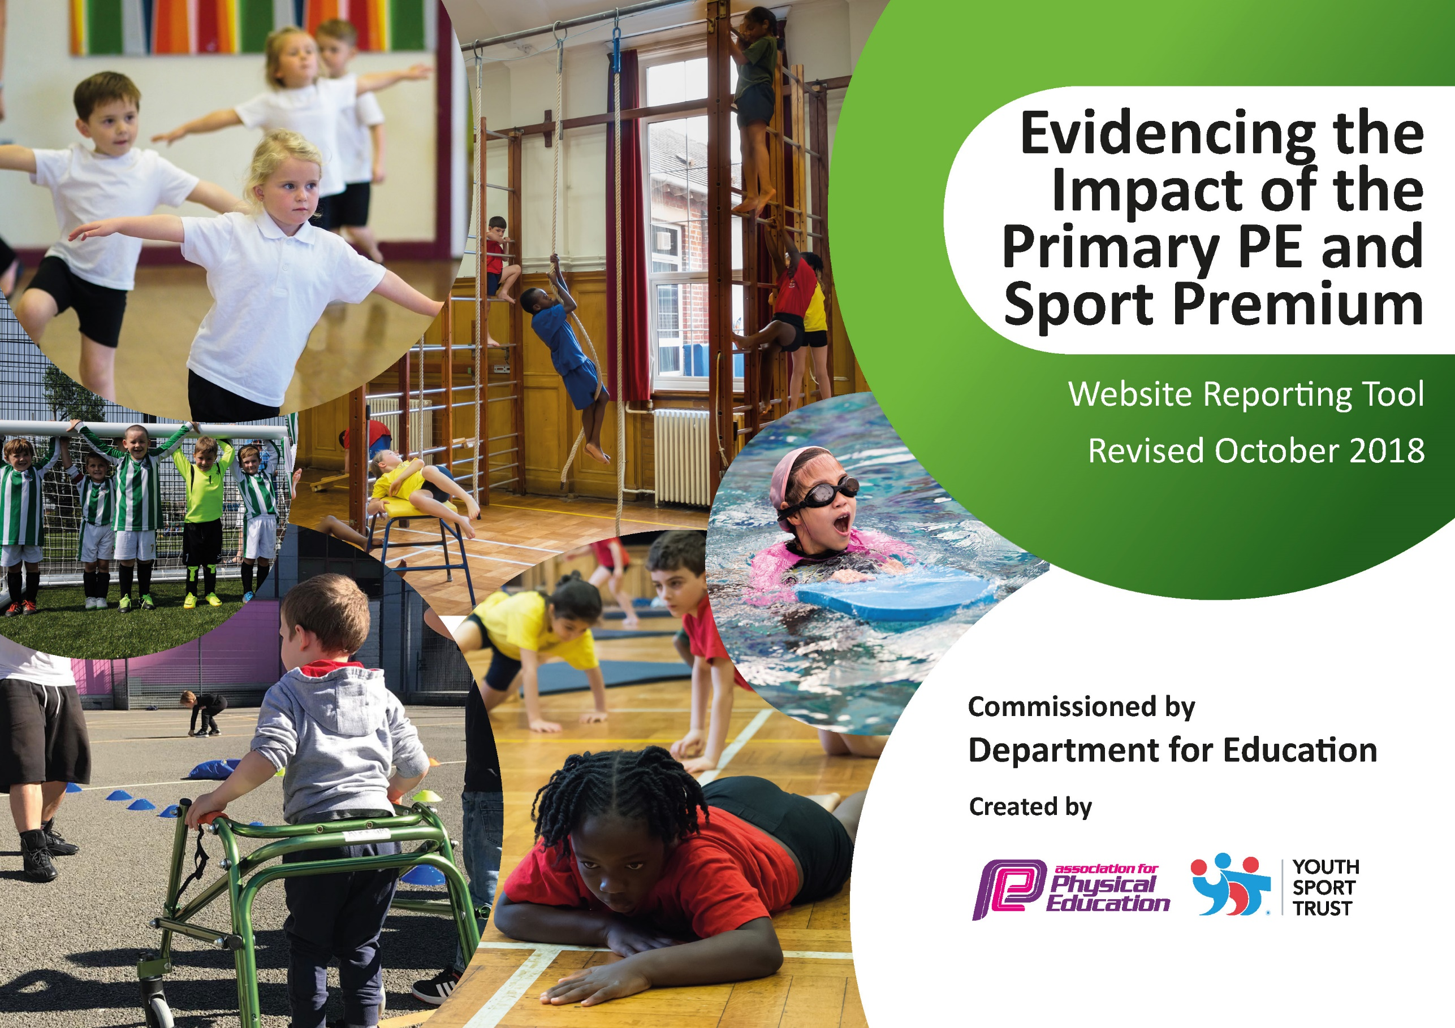
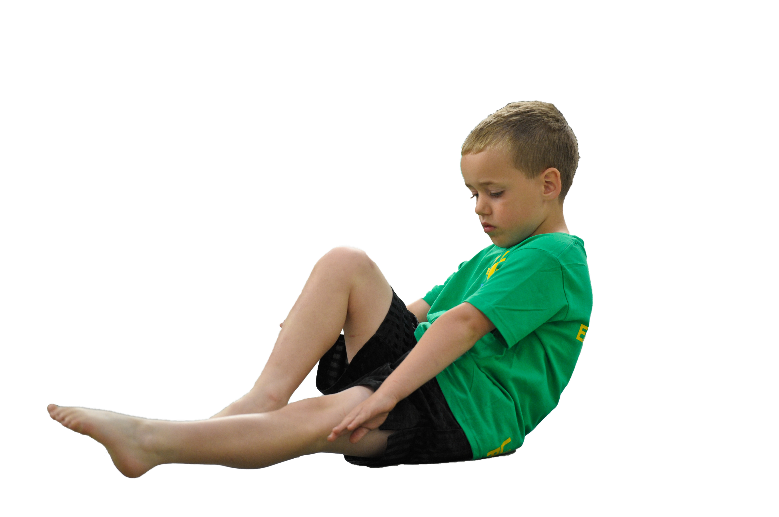
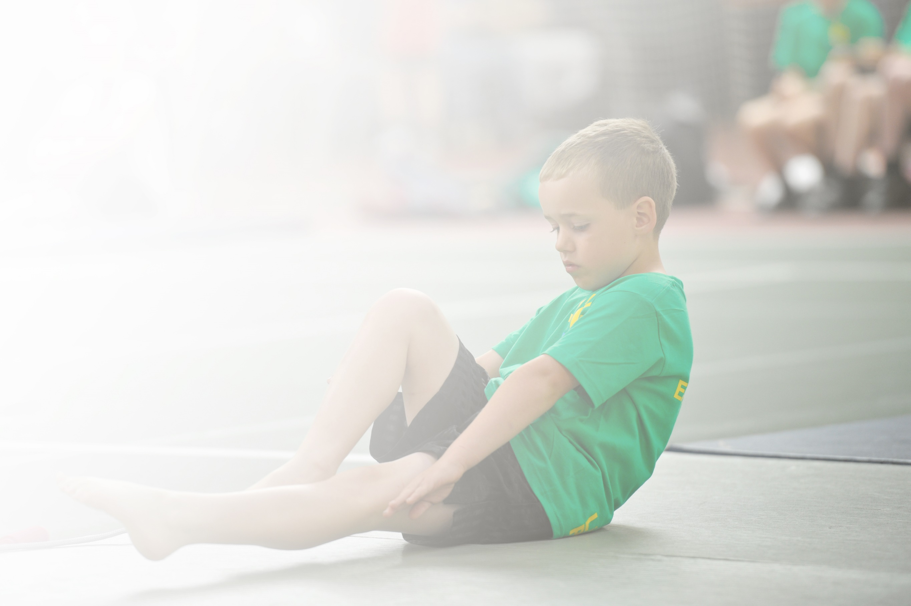
Schools must use the funding to make additional and sustainable improvements to the quality of Physical Education, Sport and Physical Activity (PESPA) they offer. This means that you should use the Primary PE and Sport Premium to:

- Develop or add to the PESPA activities that your school already offer
- Build capacity and capability within the school to ensure that improvements made now will benefit pupils joining the school in future years

Please visit gov.uk for the revised DfE guidance including the 5 key indicators across which schools should demonstrate an improvement. This document will help you to review your provision and to report
your spend. DfE encourages schools to use this template as an effective way of meeting the reporting requirements of the Primary PE and Sport Premium.

We recommend you start by reflecting on the impact of current provision and reviewing the previous
spend. Under the Ofsted Schools Inspection Framework, inspectors will assess how effectively leaders use the Primary PE and Sport Premium and measure its impact on outcomes for pupils, and how effectively governors hold them to account for this.

Schools are required to publish details of how they spend this funding as well as on the impact it has on pupils’ PE and sport participation and attainment by the end of the summer term or by 31 July 2019 at the
latest.
We recommend regularly updating the table and publishing it
on your website throughout the year, as evidence of your
ongoing review into how you are using the money to
secure maximum, sustainable impact. To see an
example of how to complete the table please
click HERE.

Support for review and reflection - considering the 5 key indicators from DfE, what development needs are a priority for your setting and your students now and why? Use the space below to reflect on previous spend, identify current need and priorities for the future.

Key achievements to date: | Areas for further improvement and baseline evidence of need:
Increased extra-curricular opportunities in and outside of school  Implementation of new class and individual assessments has allowed staff to accurately assess children’s progress.  CPD opportunities for teaching assistants have improved their delivery of a multi skills/fitness after school club.  Funding has allowed additional resources to be purchased to improve the quality of learning during PE lessons as well as after school clubs.  Children in year 5 have taken part in a sports leaders workshop which will enable them to lead activities during lunch times promoting active playtimes, improving behaviour. | Look to implement learning walks and audit the delivery of PE following CPD.  Intervention group development  Increase engagement in competition  Develop intra competitive opportunities within school  Apply for the School Games Mark and achieve silver  Develop community links with sporting clubs.  Audit our active 30 minutes and look at other ways to achieve active minutes without effecting the whole school curriculum.  Roll out the daily mile as a whole school initiative.

Meeting national curriculum requirements for swimming and water safety | Please complete all of the below:
What percentage of your current Year 6 cohort swim competently, confidently and proficiently over a distance of at least 25 metres?  N.B. Even though your children may swim in another year please report on their attainment on leaving  primary school. | 60%
What percentage of your current Year 6 cohort use a range of strokes effectively [for example, front crawl, backstroke and breaststroke]? | 60%
What percentage of your current Year 6 cohort perform safe self-rescue in different water-based situations? | 20%
Schools can choose to use the Primary PE and Sport Premium to provide additional provision for swimming but this must be for activity over and above the national curriculum requirements. Have you used it in this way? | Yes/No

Action Plan and Budget Tracking
Capture your intended annual spend against the 5 key indicators. Clarify the success criteria and evidence of impact that you intend to measure to evaluate for students today and for the future.

Academic Year: 2018/19 | Total fund allocated: £17,665 | Date Updated: July 2019
Key indicator 1: The engagement of all pupils in regular physical activity – Chief Medical Officer guidelines recommend that primary school children undertake at least 30 minutes of physical activity a day in school |  |  |  | Percentage of total allocation:
 |  |  |  | %
School focus with clarity on intended impact on pupils: | Actions to achieve: | Funding allocated: | Evidence and impact: | Sustainability and suggested next steps:
- Encourage structured play and improve behaviour at break and lunch times.  - Encourage active lunch times and assist in improving overall behaviour.  - Children across the school to have the opportunity to enjoy a range of different sports.  - Children to be inspired to learn a new sport as part of their enrichment.  - Club to encourage respect for others when playing a sport as well as creating new friendships. | Lunch time sport clubs taking place every Wednesday (Key Stage 1) and Thursday (Key stage 2) lunch time with external coaches.  Year 5 children to receive Sports Leaders training in summer term to carry out active lunch times in the next academic year.  Ensure a minimum of 3x weekly sport-focused after-school clubs which incorporate a range of sports and are accessible for children throughout school.  After-school clubs delivered by in-school and external staff:  - Fitness/Multi skills club for pupils in KS1/KS2 (alternates half-termly).  - Range of sports clubs over the year for pupils in KS1 (gymnastics; curling; dodgeball; multi skills)  - Range of sports clubs over the year for pupils in KS2 (dodgeball; basketball;fencing;athletics;boxing;football)  - All children to experience taster Futsal session.  - EYFS children to experience little kickers taster sessions.  All children take part in curriculum PE each week for one hour. Long term plan is in place.  Enrichment time has an option of dance for children to be a part of. Following the Dance Festival, rounders became a new club for the children. | Lunch time clubs with premier sport: £1080  After-school clubs with premier sport: £1321  Curricular PE with premier sport: £6189  Keep active football: £665  Sports leaders: £275 | - TAs/ lunch time staff reported improved behaviour at break/ lunch time when external coaches/ structured play in place.  - Increased attendance at after-school clubs reported.  - Children showing increased interest and enjoyment in different sports e.g. fencing and curling.  - Staff reported increased confidence in teaching PE following observations of coaches.  - Many children were inspired by the Dance Festival to compete next year. Following this, rounders was a popular option for the children.  - Staff reported excellence alongside Little Kickers taster session and they will be booked for the following year. | - Year 5 children to start Sports Leaders when in year 6 until Christmas. The next year 5 class to take their place in 2020.  - Continue to train leaders at the beginning of each academic year.  - PE lead to monitor and review on a regular basis.
Key indicator 2: The profile of PESSPA being raised across the school as a tool for whole school improvement |  |  |  | Percentage of total allocation:
 |  |  |  | %
School focus with clarity on intended impact on pupils: | Actions to achieve: | Funding allocated: | Evidence and impact: | Sustainability and suggested next steps:
- Encourage and develop parental engagement so that they are aware of PE updates.  - Promote the PE and sporting after school opportunities to children and encourage them to engage.  - Inspire other children in the school in take part in sporting events and opportunities at school and out of school.  - Celebrate our children’s PE and sporting successes and involvement.  - Purchase the Newcastle PE SLA to help support the development and implementation of a progressive PE, school sport and physical activity offer to children within the school. | Using facebook and the school website, update families on what has been happening in school to include school-sport related achievements/ goings on.  Develop and implement a process to promote and inform children, parents and staff of all competitive and healthy active lifestyle opportunities during the school calendar year.  Ensure PE notice board is updated.  Celebration assemblies following competitions allowed children to feel proud and responsible for their hard work, inspiring others in the school.  Promote sports day to parents and families and encourage attendance. | SLA: £1895 | PE notice board  School websites and newsletters  Use of social media including facebook.  Celebration assemblies  Feedback from children and parents  Sports day | A parent-child after school club has been discussed to start next year (September 2019).

Key indicator 3: Increased confidence, knowledge and skills of all staff in teaching PE and sport |  |  |  | Percentage of total allocation:
 |  |  |  | %
School focus with clarity on intended  impact on pupils: | Actions to achieve: | Funding  allocated: | Evidence and impact: | Sustainability and suggested  next steps:
- Encourage and support staff to implement their training to help all children improve in the areas required, strengthening their resilience and determination to reach a goal.  - Increase TA’s confidence by providing CPD opportunities.  - Delivery of high quality lessons and structured after school clubs to improve, impacting the children’s understanding, confidence and progress in PE. | Provide CPD opportunities for staff focusing on using assessments effectively and warm up games ideas.  External coaches working in school weekly with all classes once per term to increase TA’s confidence in teaching PE.  After school club teaching assistants to work with external coaches to support specifically their after school fitness/multiskills club across the year.  Implement new assessments to track the children’s progress half-termly in each PE unit.  SLA silver agreement: used to upskill Rachel McDowell (PE lead); support with budgeting/ spending of the sports premium funding; CPD opportunities for leaders and staff; support with action planning; identifying areas for development across the team. |  | Staff communicated increased confidence and organisation in planning and assessing.  TAs communicated increased confidence in delivering after school sessions and supporting PE sessions.  PE lead reported increased confidence in overall management of PE; managing of sports premium and so on. | - Ensure the continuous support of SLT and governors.  - PE Lead to monitor progress, confidence of teachers before and after CPD on a regular basis.  - Issue staff confidence surveys pre and post CPD.  - Use survey outcomes to identify skills/knowledge gaps and signpost staff to appropriate CPD.
Key indicator 4: Broader experience of a range of sports and activities offered to all pupils |  |  |  | Percentage of total allocation:
 |  |  |  | %
School focus with clarity on intended  impact on pupils: | Actions to achieve: | Funding  allocated: | Evidence and impact: | Sustainability and suggested  next steps:
- Facilitate a wider range of sports opportunities by ensuring the appropriate equipment and resources are available.  - Encourage children to take part in sports and activities that allow them to understand and develop core sporting values that they can apply in everyday life. Attendance to Healthy Active Lifestyle events to develop teamwork, determination and resilience across all children in school.  - Festivals to increase the ‘key experiences’ for pupils linked to sport and enrich their learning.  - Increase range of sports on offer at after-school club. | New equipment to be ordered. Ensure staff know how to use equipment.  Ensure equipment is maintained.  Attendance by all year groups at Newcastle Healthy Lifestyles events in order to increase confidence and support a change in attitude. During events, children understand and are able to demonstrate these core values (determination, self-respect, passion, teamwork, self-belief, honesty).  Festivals to be attended: dance festival, hoops4health tournament  Diwali day – Bollywood dancing | Equipment: £503.10  Dance Festival: £195  Hoops4Health: £425  Transport costs: £440 | PE notice board  School websites and newsletters  Use of social media including facebook.  Celebration assemblies  Feedback from children and parents  New equipment | Continue to attend festivals next year.  Take part in the Dance Festival next year.  Attend Healthy Active Lifestyle events.  Ensure events are booked in to the school diary in good time and the appropriate class teachers are notified.
Key indicator 5: Increased participation in competitive sport |  |  |  | Percentage of total allocation:
 |  |  |  | %
School focus with clarity on intended  impact on pupils: | Actions to achieve: | Funding  allocated: | Evidence and impact: | Sustainability and suggested  next steps:
- Encourage the engagement of children in competitive opportunities both within school and outside of school. | Engage with the School Games competition pathway  Using guidance from the School Games organiser, select and prepare children to take part in inter school competitive opportunities.  As part of preparation, encourage sportsmanship within the children linked to the core values.  Prepare children by linking the competition calendar to the PE curriculum and after school sports club.  Purchase the appropriate resources and equipment to be able to facilitate competition within school.  Take part in the Swimming Gala West Denton Pool.  Celebrate the children’s achievements. |  | Children have performed in the dance festival and competed in a range of competitions:  Y5 hoops4health  Y3/4 Quicksticks  Y1-6 Gymnastics  School Games  These opportunities have improved the children’s experience in competitive games as well as their  School games mark – Bronze TBC | Conduct survey amongst staff to see who is confident/ not confident in delivering key sports and preparing children for competition. Ensure external coaches are used to teach sports where teachers are not confident in order to increase their confidence for future competitions  Plan delivery of certain sports leading up to appropriate competitions and ensure that the curriculum links to this.  Continue to engage with the School Games programme and other pathways within the city.

