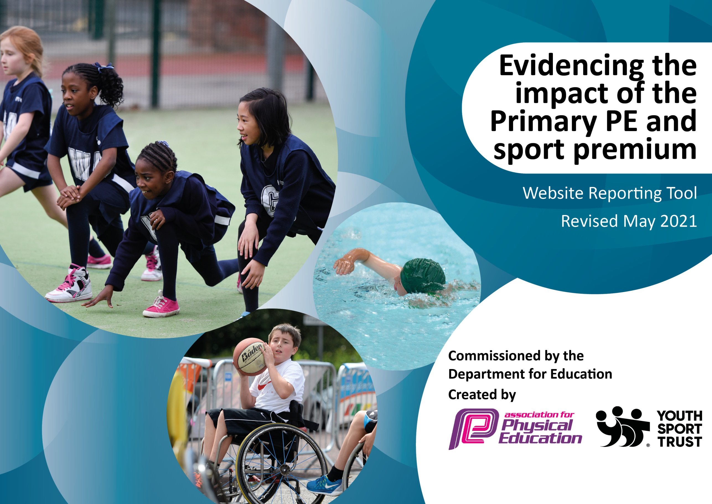

It is important that your grant is used effectively and based on school need. The Education Inspection Framework (Ofsted 2019 p64) makes clear there will be a focus on ‘whether leaders and those responsible for governors all understand their respective roles and perform these in a way that enhances the effectiveness of the school’.

Under the Quality of Education criteria (p41) inspectors consider the extent to which schools can articulate their curriculum (INTENT), construct their curriculum (IMPLEMENTATION) and demonstrate the outcomes which result (IMPACT).

To assist schools with common transferable language this template has been developed to utilise the same three headings which should make your plans easily transferable between working documents.

Schools must use the funding to make additional and sustainable improvements to the quality of Physical Education, School Sport and Physical Activity (PESSPA) they offer. This means that you should use the Primary PE and sport premium to:

- Develop or add to the PESSPA activities that your school already offer
- Build capacity and capability within the school to ensure that improvements made now will benefit pupils joining the school in future years
- The Primary PE and sport premium should not be used to fund capital spend projects; the school’s budget should fund these.
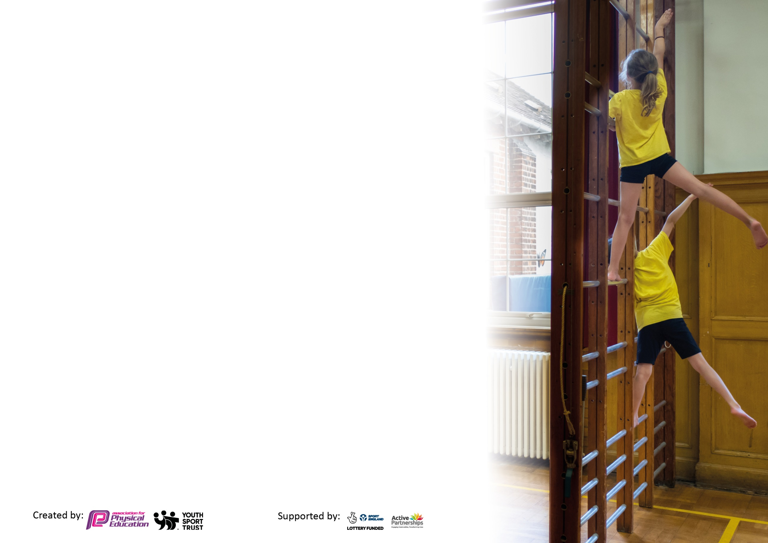
Please visit gov.uk for the revised DfE guidance including the 5 key indicators across which schools should demonstrate an improvement. This document will help you to review your provision and to report your spend. DfE encourages schools to use this template as an effective way of meeting the reporting requirements of the Primary PE and sport premium.

We recommend you start by reflecting on the impact of current provision and reviewing the previous spend.

Schools are required to publish details of how they spend this funding, including any under-spend from 2019/2020, as well as on the impact it has on pupils’ PE and sport participation and attainment by the end of the summer term or by 31st July 2021 at the latest.

We recommend regularly updating the table and publishing it on your website throughout the year. This evidences your ongoing self-evaluation of how you are using the funding to secure maximum, sustainable impact. Final copy must be posted on your website by the end of the academic year and no later than the 31st July 2021. To see an example of how to complete the table please click HERE.



Please note: Although there has been considerable disruption in 2020 it is important that you publish details on your website of how you spend the funding - this is a legal requirement.
Support for review and reflection - considering the 5 key indicators from DfE, what development needs are a priority for your setting and your pupils now and why? Use the space below to reflect on previous spend and key achievements and areas for development.

N.B. In this section you should refer to any adjustments you might have made due to Covid-19 and how these will influence further improvement.
Key achievements to date until July 2020: | Areas for further improvement and baseline evidence of need:
- A clear programme of curricular, extra-curricular PE and physical activity over lunchtime has allowed for progressive skill development in line with the National Curriculum, an increase in opportunities for all children to be active and improved pupil engagement.  - Specialist coaches have further enhanced the sports curriculum through delivery of lessons/sessions and continued staff development  - Better use of assessment information to tailor learning for individuals and provide further opportunities for poor engagers  - Coaches have been used throughout the first lockdown to provide additional PE sessions for our children in school  - PE had to go online for those children who weren’t attending school. Initiatives such as Jo Wickes’ daily sessions were promoted as well as many and varied suggestions for parents/pupils to follow around physical activity  - Parent and child after school clubs to promote physical activity amongst whole families | • Continue with the plan for year group specific after school clubs designed to target those pupils who find it harder to engage and have been assessed as needing further opportunities for skill development  • Fully resource outdoor provision in Early Years to improve opportunities for good physical development  • Better resource break times to allow for further engaging physical activity (equipment/storage)

Did you carry forward an underspend from 2019-20 academic year into the current academic year? YES/NO * Delete as applicable
Total amount carried forward from 2019/2020 £....6506..
+ Total amount for this academic year 2020/2021 £......17490
= Total to be spent by 31st July 2021 £.....23996.

Meeting national curriculum requirements for swimming and water safety.

N.B Complete this section to your best ability. For example you might have practised safe self-rescue techniques on dry land which you can transfer to the pool when school swimming restarts.
Due to exceptional circumstances priority should be given to ensuring that pupils can perform safe self rescue even
if they do not fully meet the first two requirements of the NC programme of study.
What percentage of your current Year 6 cohort swim competently, confidently and proficiently over a distance of at least 25 metres?  N.B. Even though your pupils may swim in another year please report on their attainment on leaving primary school at the end of the summer term 2021.  Please see note above. | 50%
What percentage of your current Year 6 cohort use a range of strokes effectively [for example, front crawl, backstroke and breaststroke]?  Please see note above. | 50%
What percentage of your current Year 6 cohort perform safe self-rescue in different water-based situations? | 91%
Schools can choose to use the Primary PE and sport premium to provide additional provision for swimming but this must be for activity over and above the national curriculum requirements. Have you used it in this way? | Yes/No

Action Plan and Budget Tracking
Capture your intended annual spend against the 5 key indicators. Clarify the success criteria and evidence of impact that you intend to measure to evaluate for pupils today and for the future.

Academic Year: 2020/21 | Total fund allocated: £17,490 | Date Updated: June 2021
Key indicator 1: The engagement of all pupils in regular physical activity – Chief Medical Officers guidelines recommend that primary school pupils undertake at least 30 minutes of physical activity a day in school |  |  |  | Percentage of total allocation:
 |  |  |  | %
Intent | Implementation |  | Impact
Your school focus should be clear what you want the pupils to know and be able to do and about  what they need to learn and to  consolidate through practice: | Make sure your actions to achieve are linked to your intentions: | Funding allocated: | Evidence of impact: what do pupils now know and what can they now do? What has changed?: | Sustainability and suggested next steps:
Provide opportunities across the school day and beyond for children to be physically active | Provide extracurricular PE sessions for children of all ages across school  3 x weekly lunchtime sessions with PE coach  TAs to support active minutes across break/lunchtime  Engage with online materials to promote active minutes throughout the day  Promotion of active minutes through parental communications | £1008  £152 - resources | Every child has had the opportunity to attend an after school club  Children have been introduced to a range of sports and physical activities during their lunch breaks (across KS1 and 2). Children have been more active during their breaks  As TAs have developed in confidence and competence, they have delivered activities over breaks and lunchtimes to encourage the children to be more physically active  Children have participated in Active 5 activities in class/  Jo Wickes workouts  Resources shared through school website and via class dojo  Newsletter from HT and school council promotes activities such as walking/cycling to school | Sessions reduced due to lockdown restrictions during spring term
Key indicator 2: The profile of PESSPA being raised across the school as a tool for whole school improvement |  |  |  | Percentage of total allocation:
 |  |  |  | %
Intent | Implementation |  | Impact
Your school focus should be clear what you want the pupils to know and be able to do and about  what they need to learn and to  consolidate through practice: | Make sure your actions to achieve are linked to your intentions: | Funding allocated: | Evidence of impact: what do pupils now know and what can they now do? What has changed?: | Sustainability and suggested next steps:
Provide a wider range of activities to raise the profile of sport and physical activity, motivate pupils to participate and inspire them achieve highly | Invite a range of visiting coaches into school to raise the profile of different sports (Newcastle Eagles, cricket coaches, Newcastle schools sports service)  Basic skills reward system in school to promote physical activity beyond the school gate  Participation in Active 5 event | £400 – Hoops 4 Health | Pupils have developed skills across a range of sporting disciplines. Some pupils have been inspired to pursue particular sports outside of school.  Levels of motivation and participation have increased through exposure to a wider range of sports (hockey, rugby, volleyball etc)  Children have worked hard to achieve basic skill badges which are awarded in school. Children have earned their ‘I can ride a bike unaided’ badge.

Key indicator 3: Increased confidence, knowledge and skills of all staff in teaching PE and sport |  |  |  | Percentage of total allocation:
 |  |  |  | %
Intent | Implementation |  | Impact
Your school focus should be clear | Make sure your actions to | Funding | Evidence of impact: what do | Sustainability and suggested
what you want the pupils to know | achieve are linked to your | allocated: | pupils now know and what | next steps:
and be able to do and about | intentions: |  | can they now do? What has
what they need to learn and to |  |  | changed?:
consolidate through practice:
Upskill support staff in the teaching of PE so that they can provide effective support in PE lessons and deliver high quality, engaging physical activities during break and lunchtime | PE coach to provide high quality CPD for TAs through PE lessons.  Regular meetings between PE lead and sports service | £1945 – SLA  £7490 – curricular PE staff CPD | TAs knowledge strengthened as well as confidence in teaching PE  TAs have the skills to support physical activity across beak and lunchtimes – supporting active minutes for every pupil  PE lead aware of latest initiatives, resources etc.
Key indicator 4: Broader experience of a range of sports and activities offered to all pupils |  |  |  | Percentage of total allocation:
 |  |  |  | %
Intent | Implementation |  | Impact
Your school focus should be clear | Make sure your actions to | Funding | Evidence of impact: what do | Sustainability and suggested
what you want the pupils to know | achieve are linked to your | allocated: | pupils now know and what | next steps:
and be able to do and about | intentions: |  | can they now do? What has
what they need to learn and to |  |  | changed?:
consolidate through practice:
Additional achievements:  Provide a wide range of sports and activities across the school day and beyond | Provide a varied curriculum so that children are exposed to a wide range of sporting activities (including Fantastic 4 events)  Provide extracurricular activities based on pupil choice  Increased time on site by PE coach to offer more sports activities over lunchtimes  Outward bound activity experience for oldest pupils | £4439.20 | Children have the opportunity to participate in many and varied sports and activities. Children develop an interest in particular areas and some want to pursue this outside of school  Children have the opportunity to participate in a range of physical activities at a specialist outward bound centre

Key indicator 5: Increased participation in competitive sport |  |  |  | Percentage of total allocation:
 |  |  |  | %
Intent | Implementation |  | Impact
Your school focus should be clear | Make sure your actions to | Funding | Evidence of impact: what do | Sustainability and suggested
what you want the pupils to know | achieve are linked to your | allocated: | pupils now know and what | next steps:
and be able to do and about | intentions: |  | can they now do? What has
what they need to learn and to |  |  | changed?:
consolidate through practice:
Children have the opportunity to participate in competitive events | PE coach to set half termly challenge  School sport to have a competitive element  Organise an end of year Sports Week with a competitive element | £560 | Children able to challenge themselves and strive to achieve something that their peers can do  Children have had the opportunity to take part in competitive sports as part of their PE lessons and during extracurricular PE  Children have the opportunity to take part in events with 1st, 2nd and 3rd placings to encourage competition with others | This has been impacted by Covid restrictions again this year. Plan for opportunities for inter school competitions next academic year

Signed off by
Head Teacher: | Alison Oliver
Date: | 08.07.21
Subject Leader: | Hannah Smith (currently on maternity)
Date:
Governor: | Gareth Harrison
Date: | 09.07.21

