NEWBURN JUDO CLUB
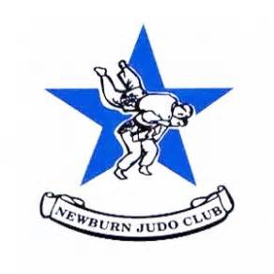
MONDAY’S & THURSDAY’S
4.30PM-5.30PM - 5-7YRS
5.30PM-7.00PM - 8+
FIRST SESSION IS FREE!
VENUE: NEWBURN ACTIVITY CENTRE
NE15 8ND
0191 2640014

